Name: | Structural formula: | Reactions: | Notes:
Soap | 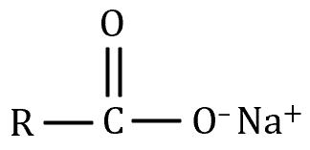  Sodium stearate | Saponification:  Triglyceride + NaOH → sodium stearate + glycerol  Example:  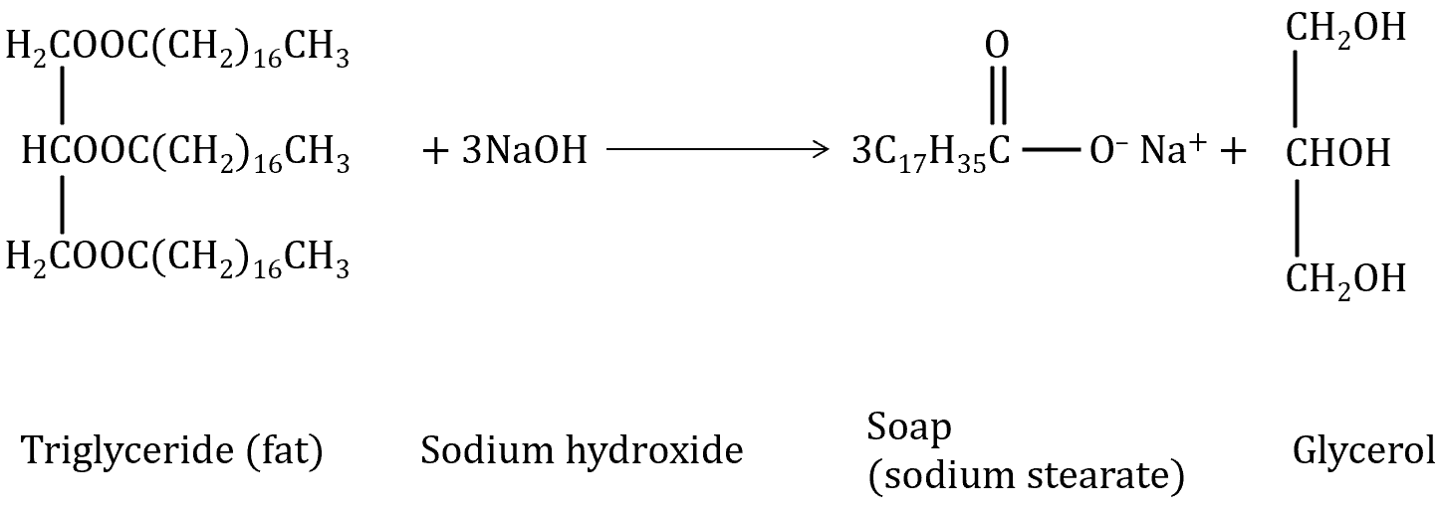 | Soaps should contain at least 13 C atoms.  Saponification is the alkaline hydrolysis (NaOH or KOH) of a plant oil or animal fat (i.e., a long-chain ester).  The long carbon chain is hydrophobic (allowing it to break up non-polar materials e.g., oil and grease) and the carboxylate end is hydrophilic (allowing it to dissolve in water).  Soaps aren’t as effective in water containing Mg²⁺ and Ca²⁺ ions (hard water) because the formation of insoluble salts stops the soap from forming the stearate ions required for their cleansing action.
Detergent | 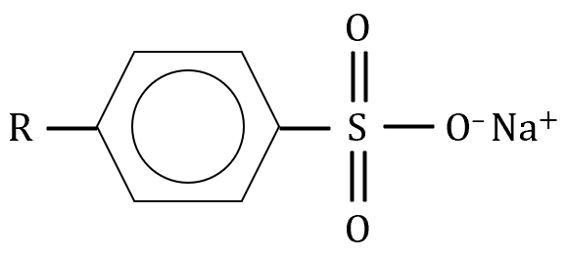 |  | Detergents are often used in hard water because they don’t form insoluble magnesium stearate or calcium stearate.  The cleaning action of detergents is very similar to that of soaps.
Biodiesel | Methyl or ethyl esters  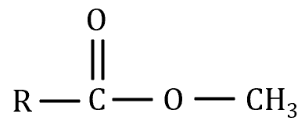 | Transesterification:  Triglyceride + alcohol ⇌ ester + glycerol  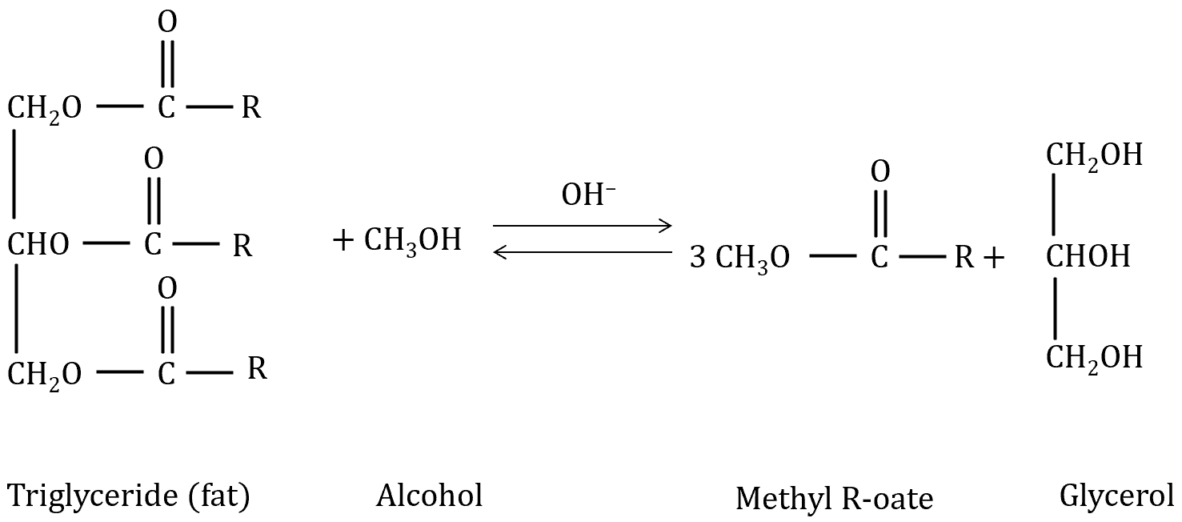 | Biodiesels should contain 8-21 C atoms.  OH– ions are used as a catalyst.

Cleansing action of soaps:
- The non-polar region of the soap molecule is attracted to the non-polar oil/grease. The polar end of the soap molecule is attracted to the water molecules. This attraction pulls pieces of the oil or grease away from the main chunk.
- Agitation will help the soap molecules break up the oil and grease down into smaller pieces. The soap molecules completely surround the tiny oil droplet and the attraction between the carboxylate region of the soap molecule and the water molecules allows the mixture to dissolve in water.

Synthesis of ethanol:
Fermentation: Yeast converts simple sugars/monosaccharides (corn, sugar cane and sorghum are common sources) into alcohol and CO₂.
Step 1: Grain is dried and crushed to release starch, a polymer made up of repeating units of monosaccharides, glucose or fructose.
Step 2: Water and the enzymes, amylase and amylase

